5. Working and functioning of different Buses, I/O Ports, graphic cards.
To learn about different ports and how to connect devices to them. This diagram shows different ports available on the back panel of the PC.
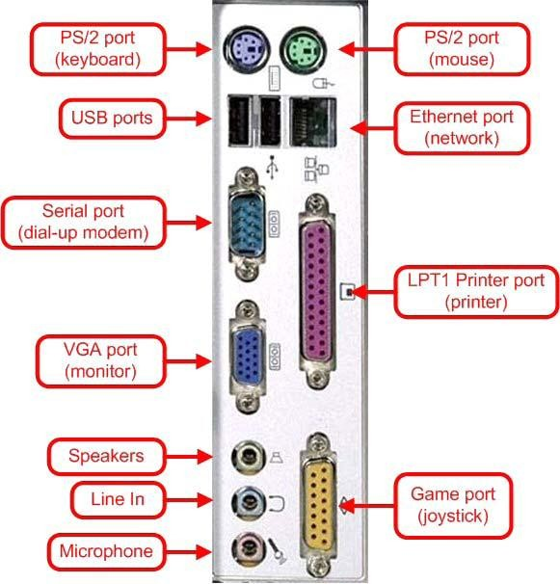
Parallel port (LPT parallel port):
As shown in the diagram parallel port with 25-pins can be used to connect a parallel port printer.
Previously dot matrix, ink jet, bubble jet printers etc were connected to parallel port. Now a days parallel port is used to connect Dot-Matrix printers.
Serial port:
As shown in the diagram serial ports with 9-pins protruding outwards can be used to connect modem but it can also be used for connecting mouse, provided serial port mouse is available.
VGA Port:
VGA port which has 15-pins is used to connect a monitor.
PS/2 Port:
Two 6-pin PS/2 ports are there, one is violet to which keyboard is connected and other is Light green to which mouse is connected.
USB Port:
Connecting a USB device to a computer is simple — you find the USB connector on the back of your machine and plug the USB connector into it. USB ports are used to connect to Inkjet printers, Web Cams, Scanners etc.
Ethernet Port:
Ethernet port is used to connect a computer on network through RJ-45 connector.
Game Port:
Game Port is used to connect joystick, which is usually used in video games.
Three more ports are available for multimedia connections. Green port is used connect speakers, blue port is used to connect headphones and light Orange is used to connect microphone.
Sound card:
A sound card or audio board, which allows computers to output audio signals through speakers
and or headphones.
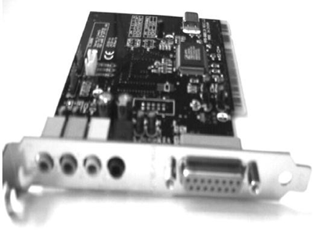
Video card:
The video card is responsible for creating all that you see on your computer monitor.
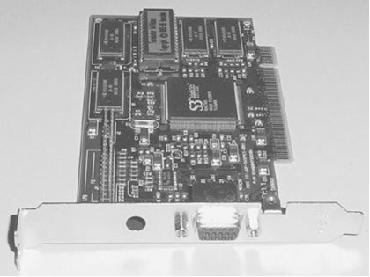
Network card:
This piece of hardware allows your computer to be connected to a network of other computers
(known as a LAN or Local Area Network)
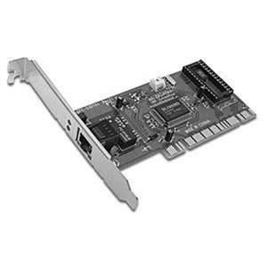
Procedure to install a sound card
1. Remove any unnecessary temporary metal plates. Only remove the metal plates from the slots you are going to use. If you do not remove these, you cannot install any PCI components. Most either unscrew or pop out.
2. Locate PCI Slots on Motherboard. Your PCI Slots should look similar to the ones in the image below
3. Line up component with PCI slot and install. Simply line up the component with the slot and gently press down on both sides until it slides in place.
4. Insert screw. There is only one screw needed to secure each PCI component in place.
5. Give it CD Sound. Remember that audio cable from the CD-ROM drive? Now we will connect the other end of it. If you want to hear audio when play a cd in your CD-ROM, you need to connect the CD-ROM to the Sound Card (or motherboard if your sound card is integrated in) using the audio cable as seen below. Refer to your sound card owner’s manual for correct placement. If you did not purchase a sound card and you have one integrated into your motherboard, refer to your motherboard owner’s manual for correct placement
6. Repeat for any other components. Every component is different but as long as its PCI compatible, it is installed the same way (except for the audio cable. It is installed only on sound cards and motherboards.)

